{Zhao, 2018 #73} maize

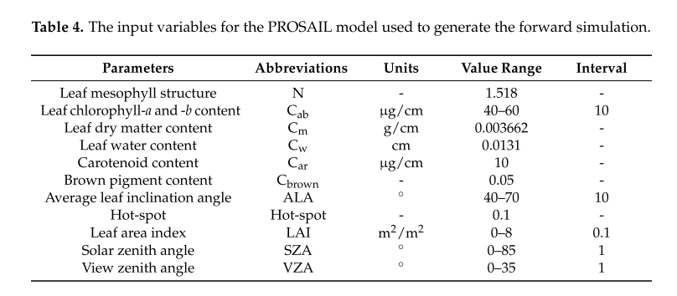

{Zou, 2018 #61} Faba bean, Narrow-leafed lupin, Turnip rape, Oat, Barley, Wheat

Leaf angle computation from sensor

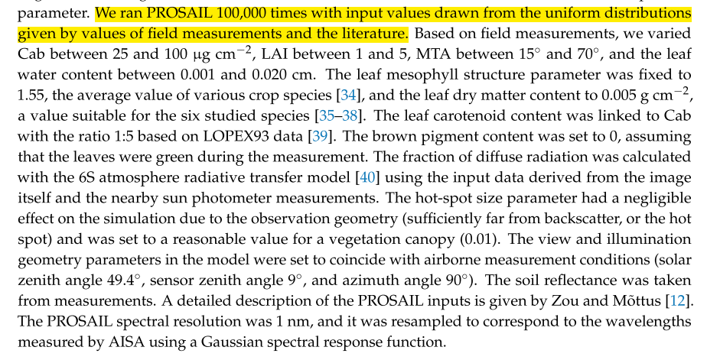

{Zhu, 2018 #67} maize and wheat

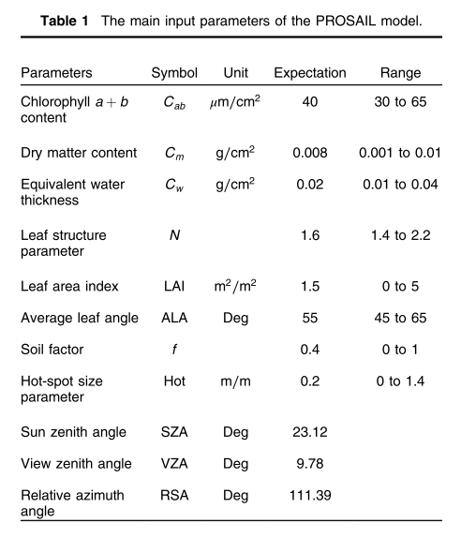

{Zhang, 2018 #66}

In total, 20,000 vegetation parameter combinations were generated using the Satellite periodic function [45] by the uniform sampling of nine leaf and canopy parameters over the ranges that are shown in Table 1 with reference to the experimental designs of previous studies [43,44], except for Cbrown and SKYL.

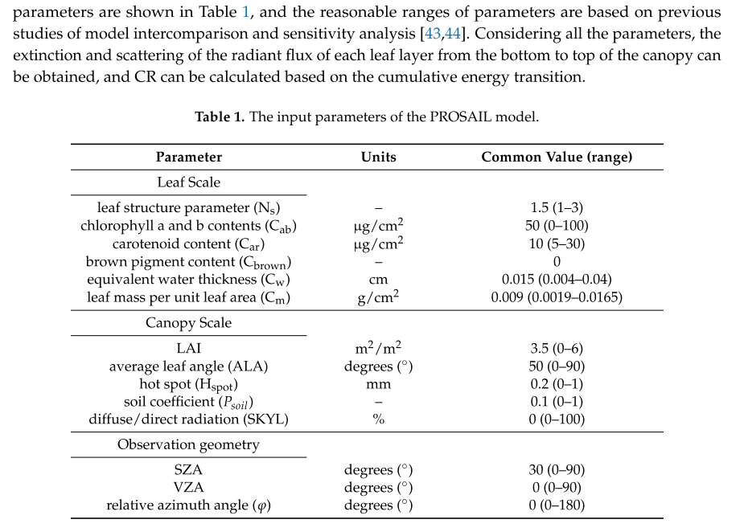

{Roosjen, 2018 #65}

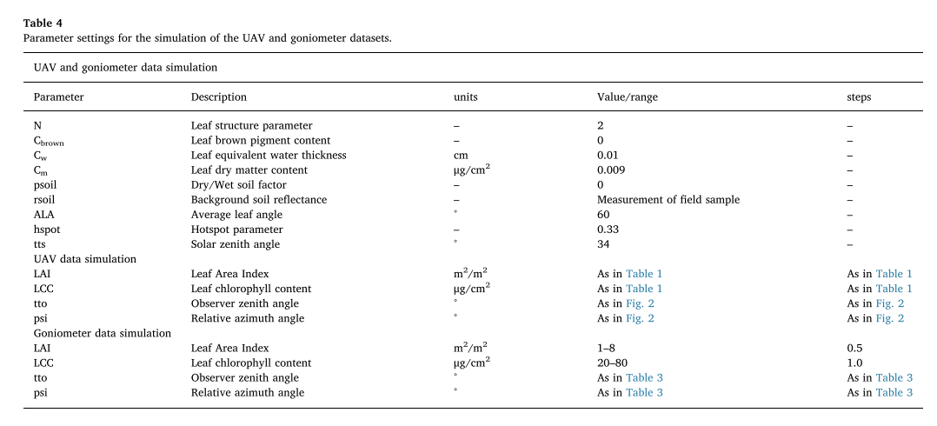

{Punalekar, 2018 #58} herb and grass species in grasslands

N=1.6, q=0.05, LIDFb=-0.15, LAI/Cab/Cm/Cw were sampled using distribution function suggested by Weiss et al. (2000), LIDFa and Cbp were sampled using uniform distribution. 20000 random combinations of these parameters were generated according to pre-defined parameter ranges (Table S1)

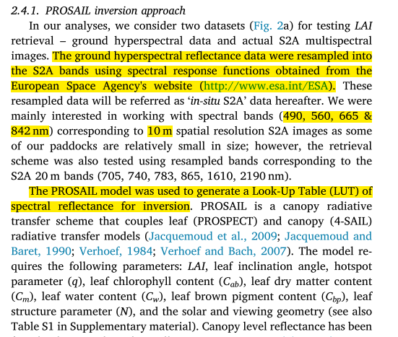

{Li, 2018 #64} winter wheat涉及波段组合的选择

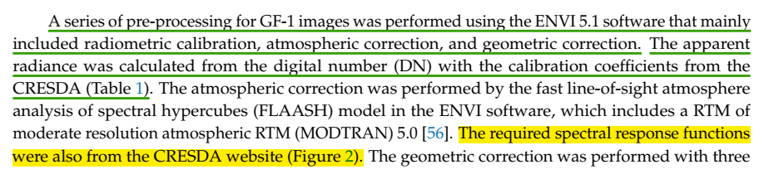

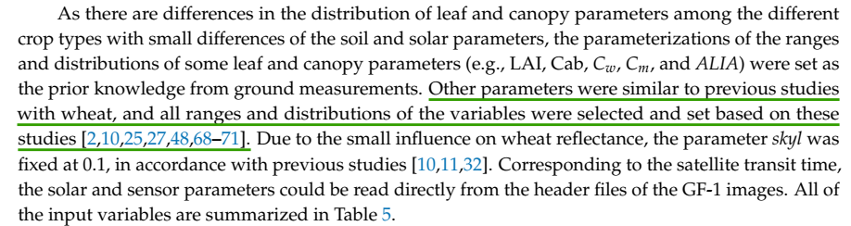

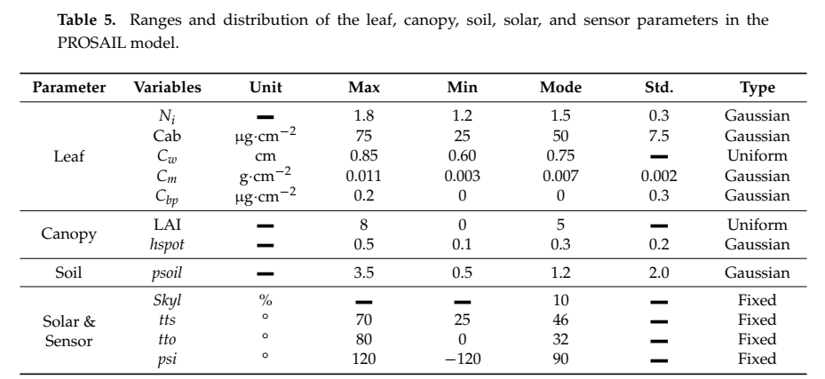

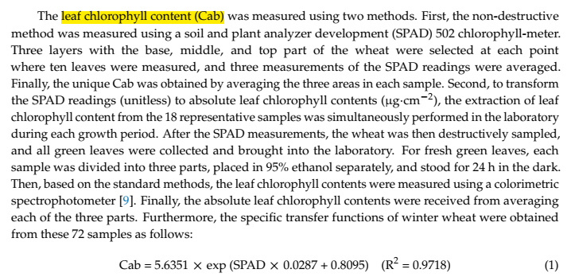

{Li, 2018 #60}

实验测量日期及方法

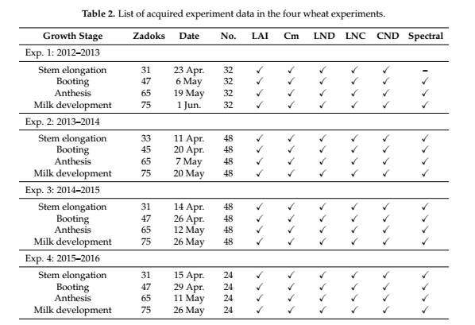



LAI: Laser leaf area meter (CI-203, CID Bio-Science Inc., WA, USA).

leaf N concentration (LNC, %): Carlo-Erba NA 1500 dry combustion analyzer (Carlo Erba, Milan, Italy)

{Garcia-Haro, 2018 #63} global vegetation

涉及对反射率增加噪声的处理，多模型比较（NN,KRR,GPR），分析样本数目对估算精度的影响，强调多变量同时估算方法的优势（相对于单变量分别估算方法）

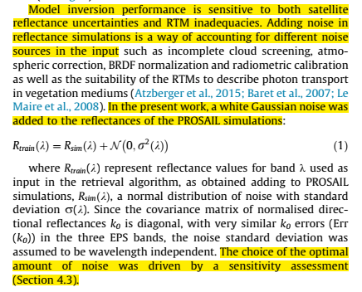

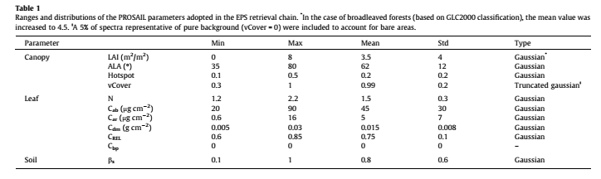

{Campos-Taberner, 2018 #62} globe vegetation

涉及对反射率增加噪声的处理,inversion method使用随机森林回归（random forest）

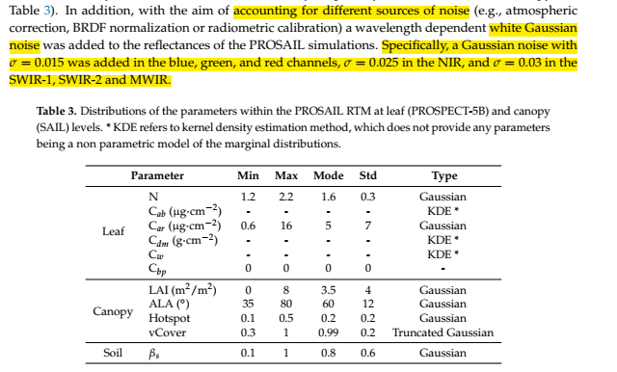

{Berger, 2018 #72}

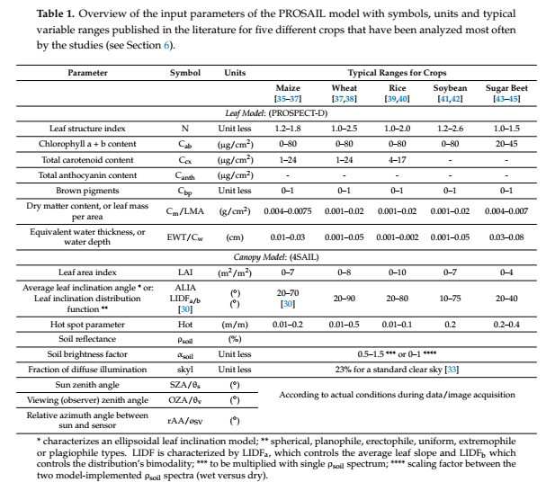

{Danner, 2017 #77}winter wheat

探索多角度反射率的应用（multiple viewing zenith angle issue）

